1 | Pilar GEIJO | ARG | 7:11.58
2 | Esther NUNEZ | ESP | 7:23.15
3 | Joanie GUILLEMETTE-SIMARD | CAN | 7:23.55
4 | Aurelie COTE | CAN | 7:59.24
5 | Rita Vanessa GARCIA | ARG | 8:19.16
6 | Gabrielle TROTTIER | CAN | 8:34.44
7 | Ronnica CHRISTIE | CAN | 8:43.34
8 | Irene VAN DER LAAN | NED | 9:09.27

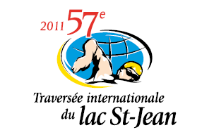

Open Water Swimming Grand Prix 2011 Lac St-Jean (CAN) - Mujeres

Open Water Swimming Grand Prix 2011 Lac St-Jean (CAN) - Varones

1 | Petar STOYCHEV | BUL | 6:36.30
2 | Simon TOBIN | CAN | 3:67.52
3 | Tomi STEFANOVSKI | MKD | 6:46.31
4 | Andrea VOLPINI | ITA | 6:50.37
5 | Trent GRIMSEY | AUS | 6:52.02
6 | Evgenij POP ACEV | MKD | 6:55.12
7 | Ian VAN DER HULST | NED | 7:02.02
8 | Luciano MARTIN SALES RUBIO | ARG | 7:03.36
9 | Eric NILSSON | USA | 7:29.12
10 | Paul BLAIS-MORISSET | CAN | 7:30.01
11 | Soren MIKKELSEN | DEN | 7:51.59
12 | Jean-Luc FORTIN-DIONNE | CAN | 8:06.23
13 | Pierre PELLETIER | CAN | 8:33.00

