Classement | Distance  parcourrue | Moyenne | Temps restant estime | Temps  Total estime | Pays
1. Trent Grimsey (#10) | 34 km 0 m | 4.60 km/h | 0 H 0 M | 7h24m38s | 
2. Xavier Desharnais (#21) | 34 km 0 m | 4.52 km/h | 0 H 0 M | 7h30m52s | 
3. Damian Blaum (#20) | 34 km 0 m | 4.50 km/h | 0 H 0 M | 7h30m53s | 
4. Luciano Martin Sales Rubio (#19) | 34 km 0 m | 4.51 km/h | 0 H 0 M | 7h31m01s
5. Alexander Studzinski (#5) | 34 km 0 m | 4.54 km/h | 0 H 0 M | 7h31m02s | 
6. Evgenij Pop Acev (#3) | 34 km 0 m | 4.52 km/h | 0 H 0 M | 7h32m03s | 
7. Andrea Volpini (#13) | 34 km 0 m | 4.41 km/h | 0 H 0 M | 7h42m03s | 
8. Ian Van der Hulst (#8) | 34 km 0 m | 4.32 km/h | 0 H 0 M | 7h52m29s | 
9. Esther Nunez Morera (#4) | 34 km 0 m | 4.30 km/h | 0 H 0 M | 7h55m17s | 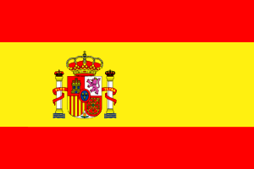
10. Pilar Geijo (#15) | 34 km 0 m | 4.14 km/h | 0 H 0 M | 7h56m38s
11. Anna Uvarova (#22) | 34 km 0 m | 4.17 km/h | 0 H 0 M | 8h04m27s | 
12. Paul Blais-Morisset (#2) | 34 km 0 m | 3.98 km/h | 0 H 0 M | 8h29m54s
13. Antonella Bogarin (#12) | 34 km 0 m | 3.98 km/h | 0 H 0 M | 8h30m50s
14. Marianela-Elizabet Mendoza (#11) | 34 km 0 m | 3.93 km/h | 0 H 0 M | 8h39m08s
15. Aurelie Cote (#7) | 34 km 0 m | 3.79 km/h | 0 H 0 M | 8h58m27s
16. Noella Petti (#6) | 34 km 0 m | 3.71 km/h | 0 H 0 M | 9h11m55s
17. Pierre Pelletier (#14) | 34 km 0 m | 3.69 km/h | 0 H 0 M | 9h14m00s
18. Rita Vanesa Garcia (#9) | 34 km 0 m | 3.61 km/h | 0 H 0 M | 9h26m10s
19. Ivana Sitic (#1) | 34 km 0 m | 3.53 km/h | 0 H 0 M | 9h39m48s | 
, 20. Gabrielle Trottier (#17) | 34 km 0 m | 3.44 km/h | 0 H 0 M | 9 H 53 M

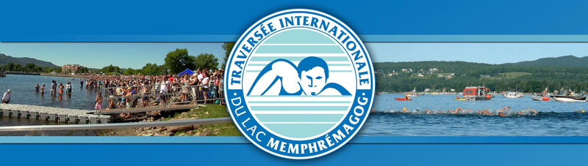

Clasificación General

Clasificación Varones

Classement Homme | Pays
7h24m38s, 1. Trent Grimsey (#10)
7h30m52s, 2. Xavier Desharnais (#21)
7h30m53s, 3. Damian Blaum (#20)
7h31m01s, 4. Luciano Martin Sales Rubio (#19)
7h31m02s, 5. Alexander Studzinski (#5)
7h32m03s, 6. Evgenij Pop Acev (#3)
7h42m03s, 7. Andrea Volpini (#13)
7h52m29s, 8. Ian Van der Hulst (#8)
8h29m54s, 9. Paul Blais-Morisset (#2)
9h14m00s, 10. Pierre Pelletier (#14)

Clasificación Mujeres

Classement Femme | Pays
7h55m17s, 1. Esther Nunez Morera (#4)
7h56m38s, 2. Pilar Geijo (#15)
8h04m27s, 3. Anna Uvarova (#22)
8h30m50s, 4. Antonella Bogarin (#12)
8h39m08s, 5. Marianela-Elizabet Mendoza (#11)
8h58m27s, 6. Aurelie Cote (#7)
9h11m55s, 7. Noella Petti (#6)
9h26m10s, 8. Rita Vanesa Garcia (#9)
9h39m48s, 9. Ivana Sitic (#1)
, 10. Gabrielle Trottier (#17)

Retrait | Pays
, 1. Tomi Stefanovski (#18)

