


25 KM VARONES
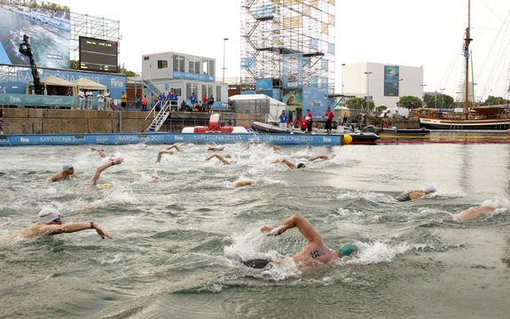

8º BERTOLA Guillermo Vittorio ARG 4:47:44.8

SPLIT 1 | SPLIT 2 | SPLIT 3 | SPLIT 4 | SPLIT 5 | SPLIT 6 | SPLIT 7 | SPLIT 8 | SPLIT 9 | FINISH
(10)  31:12.2 | (17)  1:00:34.2  29:22.0 | (27)  1:28:59.4  28:25.2 | (19)  1:56:42.2  27:42.8 | (18)  2:24:46.5  28:04.3 | (16)  2:53:11.6  28:25.1 | (1)  3:21:48.0  28:36.4 | (15)  3:51:13.8  29:25.8 | (10)  4:20:03.7  28:49.9 | 4:47:44.8

25º CARRIZO YUNGES, Martin Miguel ARG 5:01:43.1

SPLIT 1 | SPLIT 2 | SPLIT 3 | SPLIT 4 | SPLIT 5 | SPLIT 6 | SPLIT 7 | SPLIT 8 | SPLIT 9 | FINISH
(29)  14:16.1 | (13)  1:00:32.8  28:56.4 | (30)  1:29:01.5  28:28.7 | (21)  1:56:44.0  27:42.5 | (20)  2:24:49.2  28:05.2 | (22)  2:53:17.6  28:28.4 | (26)  3:25:08.8  31:51.2 | (25)  3:57:00.0  31:51.2 | (26)  4:29:40.9  32:40.9 | 5:01:43.1

25 KM MUJERES
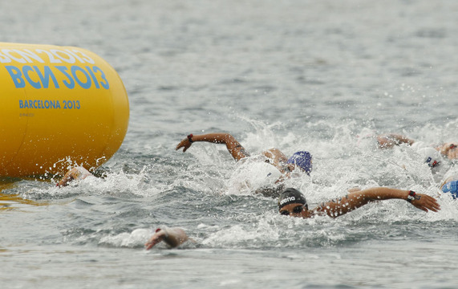

15º ARINO, Julia Lucila ARG 5:22:47.0

SPLIT 1 | SPLIT 2 | SPLIT 3 | SPLIT 4 | SPLIT 5 | SPLIT 6 | SPLIT 7 | SPLIT 8 | SPLIT 9 | FINISH
(14)  15:27.3 | (13)  1:05:47.6  31:56.8 | (16)  1:37:44.7  31:57.1 | (10)  2:09:42.4  31:57.7 | (17)  2:40:45.0  31:02.6 | (17)  3:12:35.9  31:50.9 | (14)  3:45:08.5  32:32.6 | (15)  4:18:05.6  32:57.1 | (15)  4:51:24.3  33:18.7 | 5:22:47.0

