

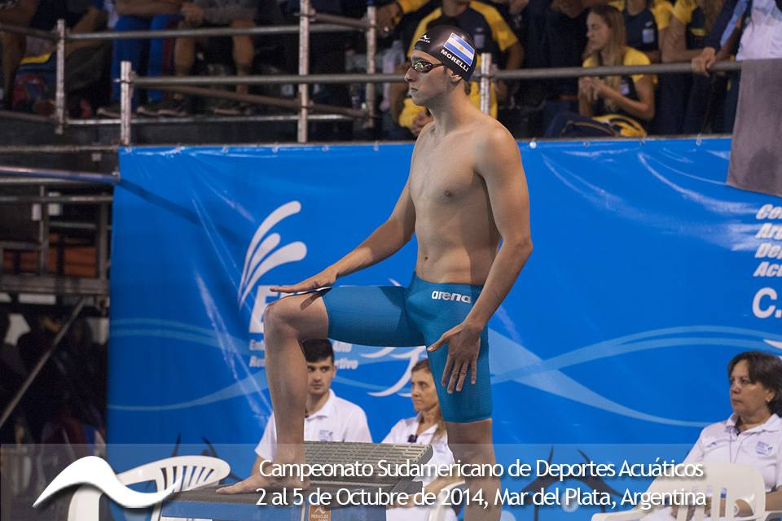

Foto: HERACLES TEAM
El nadador MORELLI, Gabriel del Club Gimnasia y Esgrima de Santa Fe compitió en los 100 mts pecho.
Evento 8 Hombres 100 CL Metro Estilo de Pecho
=========================================================================
SUDAMERICANO: S 59.03
ARGENTINO AB: A 1:01.42
1:00.44 KA MUNDIAL KAZAN
1:02.56 KB MUNDIAL KAZAN
1:02.79 PA PANAMERICANO A
Nombre Edad Equipo Elimin Finales Puntos
=========================================================================
=== Finales ===

1 Alves Franca DA BRA 1:03.59 1:01.26AKB
29.19 1:01.26 (32.07)
2 Gomes Junior, J BRA 1:03.09 1:02.35 KB
29.41 1:02.35 (32.94)
3 Miguelena, Facu ARG 1:03.84 1:02.41 KB
29.30 1:02.41 (33.11)
4 Mahecha Pinto, COL 1:03.34 1:03.16
29.94 1:03.16 (33.22)
5 Crespo, Edgar 25 PAN 1:03.82 1:03.36
29.43 1:03.36 (33.93)
6 Morelli, Gabrie ARG 1:05.37 1:05.23
30.19 1:05.23 (35.04)
7 Won Siu, Santia PERU 1:06.71 1:06.82
31.29 1:06.82 (35.53)
8 Fuenzalida Gonz CHI 1:08.30 1:08.18
30.90 1:08.18 (37.28)
9 Quiroz Uteau, F CHI 1:08.39 1:08.39

